Beyond Distance: A Statistically-Validated Framework for
Measuring Ball-Carrying Effectiveness in Elite Football

Abstract
Football statistics, which follow the outcomes, tell little about the physical and spatial mechanics of ball-carrying – how far and how fast the ball moved, how many real defenders were passed – and how many real attacking effects did it gain? This thesis creates and statistically validates a real-data framework to measure precisely that, through StatsBomb's open event and 360° freeze-frame release, over 16,472 real carries from 25 named midfielders and attackers over two separate competitions: La Liga 2020/21 season (Barcelona) and Ligue 1 2021/22 season (Paris Saint Germain). A zone-aware progressive-carry metric is defined and validated via a held-out grid search, and is connected to real 2-D spatial line-breaking metrics (DBSCAN clustering, convex hulls and path intersection over real 360° opponent positions), with an initial 1-D heuristic replaced. Standard errors, p-values, and 95% confidence intervals are performed on all regression-based findings, and are not just reported as a point estimate. The central and twice replicated finding is that zone-aware progression is a much more robust predictor of real line-breaking and real pitch-control gain, both in itself and with statistical formalism, than is the raw carry distance in both competitions. Further, formal hypothesis testing reveals that none of the individual fixed effects of the players are statistically distinguishable from context in La Liga 2020/21, and one, namely Messi (his first season at PSG), indicates a statistically significant positive effect (p = 0.005), robust to progressive-carry rate correction. The thesis makes a reproducible and open data pipeline; two carry over metrics from cited football-analytics practice that were not invented ad hoc: formal inference, and two-season replication; and proves that the research process developed to be robust to methodological review can result in a material change in the final headline conclusion.

Table of Contents
Abstract
Acknowledgement
List of Figures
List of Tables
Chapter 1 Introduction
1.1 Background
1.2 Motivation
1.3 Problem Statement
1.4 Research Objectives
1.5 Research Questions
1.6 Methodology
1.7 Scope and Limitations
Chapter 2 Literature Review
2.1 Outcome-Based versus Spatial Analytics in Football
2.2 Tracking-Data Quality and Measurement Validity
2.3 Anthropometric Foundations for Physical Metrics
2.4 Progressive Carrying and Line-Breaking as Analytics Concepts
2.5 Key Findings and Research Gap
Chapter 3 Methodology and Implementation
3.1 Research Design Overview
3.2 Data Source and Coverage
3.3 Player Selection
3.4 Metric Definition and Initial Specification
3.5 Parameter Validation via Grid Search
3.6 The 2-D Spatial Upgrade and a Development Correction
3.7 Pitch Control Implementation
3.8 Multi-Phase Downstream Value Linkage
3.9 Statistical Inference Methodology
3.10 Implementation Architecture
3.11 Threats to Validity
Chapter 4 Results
4.1 Descriptive Results
4.2 Predictive Modelling Results
4.3 Formal Statistical Inference Results
4.4 Replication Across Seasons
Chapter 5 Discussion
Chapter 6 Conclusion
6.1 Summary
6.2 Research Questions Revisited
6.3 Contribution Statement
6.4 Future Work
References

List of Figures
Figure 3.1 Season 1 Descriptive Dashboard: Speed Distribution, Mass Sensitivity, Line-Break Rates, Feature Importance
Figure 3.2 2-D Line-Break Detection Example: Convex Hulls over Real 360° Opponent Positions
Figure 3.3 Static Voronoi Pitch Control Around a Real Carry
Figure 4.1 Methodological Validation Dashboard: Grid Search, xG Linkage, Season-2 Replication, AUC Comparison
Figure 4.2 Player Fixed Effects with 95% Confidence Intervals, Both Seasons (Forest Plot)

List of Tables
Table 1.1 Research Questions and Corresponding Thesis Chapters
Table 3.1 Dataset Coverage, Both Seasons
Table 3.2 Featured Player Roster, Season 1 (La Liga)
Table 3.3 Featured Player Roster, Season 2 (Ligue 1)
Table 3.4 1-D Clustering Gap Grid Search (Initial Specification)
Table 3.5 2-D Spatial Parameter Grid Search (Final Specification)
Table 3.6 Finalized Six-Feature Model Specification
Table 4.1 Season 1 Descriptive Statistics
Table 4.2 Season 2 Descriptive Statistics
Table 4.3 Progressive Carry vs. Line-Break Overlap, Both Seasons
Table 4.4 OLS Regression: Predictors of Pitch-Control Gained
Table 4.5 Logistic Regression: Predictors of Line-Breaking (Six-Feature Baseline)
Table 4.6 Player Fixed Effects, Season 1 (La Liga)
Table 4.7 Player Fixed Effects, Season 2 (Ligue 1)
Table 4.8 Bootstrap 95% Confidence Intervals for Classifier AUC
Table 6.1 Summary of Research Questions and Findings

Chapter 1: Introduction

1.1 Background
Modern football analytics has grown in a few areas, in particular around two types of data: event data is data that is noting when something happens (passes, carries, shots) and what the location of that data is (where did the ball go, where was the player, etc.) and tracking data is the continuous position of each player on the pitch. While outcome-based measures—goals, assists, pass completion percentage—have always been the public side of the sport's analytics, they provide little insight into the physical and spatial mechanics involved in creating the outcome - how far the player went with the ball, how fast, past how many actual opponents, and with what actual attacking effect. Descriptions like ‘direct,' ‘progressive' and ‘able to beat a man' are used to describe elite ball carriers like Lionel Messi, Kylian Mbappé and Ricardo Kaká, but have not been translated into measurable, repeatable or falsifiable terms.
What is now possible outside clubs' own analytics department has changed with the public release of high resolution tracking style information. The open data programme is a key part of StatsBomb, and they make event data and 360° freeze frame opponent positions available free of charge for a certain number of competitions and seasons — full-season data for Barcelona's 2020/21 La Liga campaign and Paris Saint-Germain's 2021/22 Ligue 1 campaign are two seasons that span the timeline of Lionel Messi, who played for two clubs, one year apart. The following thesis uses that release to construct a measurement framework for ball-carrying that makes its assumptions transparent, explicitly checks them out against held-out data not simply asserted, and tests it to see if it's robust enough to be applied to a second, independent league and season.

1.2 Motivation
This work comes from a disconnect between the motivation of football analytics and the actual measurements. Carry statistics that relate to obstacles based on distance or count ('progressive carries', 'carries into the final third') are also popularly used in public analyses of the game but are not often compared to an explicit alternative, seldom associated with measured downstream attacking value, and nearly never accompanied by an expression of statistical uncertainty. To claim that one player ‘breaks lines’ more than another is – in most published analytics efforts – a comparison of two point estimates without any means of indicating that the difference may be due to sampling noise.
That gap is the real problem that is addressed in this thesis. The attempt is not to assume that a simple, one-dimensional sense of ‘line-breaking' is sufficient, or that a raw ‘distance' based carry measure reflects ‘progression', but one definitional choice after another is laid out, examined against an alternative, and (where a real improvement exists, as when one-dimensional ‘clustering' is replaced by real two dimensional ‘spatial geometry') upgraded and re-validated. Uncertainty is also quantified when a result is plausibly a statistical artefact of a small sample. In short, the motivation is to illustrate that a football-analytics pipeline can, like any other empirical research process, be subjected to the same level of methodological scrutiny and to show, concretely, what that means when it is.

1.3 Problem Statement
Carry-level and progression-based are growing metrics in public football analytics, however, there are a number of limitations in these approaches that are directly addressed in this thesis.
Gap 1: The carry distance and ‘progressive carry' measures used in most public games do not consider the starting point of a carry; an 8-metre carry in a team's own half is the same as an 8-metre carry on the edge of the penalty area. In football-analytics practice there is an equivalent definition for a zone-aware, but it is not actually, as far as I can tell, explicitly stated in a cited formula and compared to the zone-blind alternative.
Gap 2: Published attempts to detect ‘line-breaking' from event data or tracking data usually take only a one dimensional view of the shape (usually depth), failing to use the real lateral (width) information that comes with modern freeze frame data. Technically, it is easy to develop a two dimensional spatial method but one based on the actual position of possible opponents, not just a single summary coordinate, is not widely used in the openly available analytical work that is based on real data.
Gap 3: Rarely do attackers carry-level metrics (expected goals or xG) get correlated to real measured attacking value (expected goals or xG) at the other end, where possession is briefly transferred by a blocked shot rebound or a loose ball won back in just seconds before the attacking side's attack is resumed.
Gap 4: When comparing players based on metrics involving carries, the comparisons are almost always expressed as point estimates. Standard errors, confidence intervals, and hypothesis tests are not used to perform formal statistical inferences when comparing player levels in the public discourse of the sport, making it hard to distinguish between a real effect and noise, especially for players with small sample sizes.
Gap 5: A common drawback of football analytics findings is that they are often presented for a single season or event. Replication — running the same pipeline on a second, independent dataset — is uncommon, and so the question remains as to whether a particular finding is due to a real phenomenon in football or is an artefact of one particular dataset.

1.4 Research Objectives
Primary Objective: To design and statistically validate a simple, repeatable, real data-based method to assess the effectiveness of ball carrying in elite football, which is able to differentiate between real ball carrying contextually and real ball breaking of the defensive line and distance-based heuristics, and to determine if the individual player's identity adds explanatory value beyond situational context, with all conclusions to be formally statistically inferred and verified with a replication over two seasons.
Specific Objectives:
- Collect and verify real event and 360° tracking data from an open, freely available source with data from multiple leagues and seasons.
- Calculate and use a zone-aware progressive-carry measure, based upon an existing cited football-analytics definition, not an invented one.
- The design, validation (using held-out grid search) and implementation of a genuinely two dimensional spatial approach to identify defensive line breaking (clustering, convex hulls, path intersection over real opponent positions) in contrast to an initial one dimensional heuristic.
- Match possession structure also covers multi-phase (chained) possession that a single possession definition would not.Match possession structure is used to link to real downstream attacking value including multi-phase (chained) possession that would not be captured by a single possession definition.
- Report standard errors, confidence intervals, and hypothesis tests, not just point estimates, for all regression-based results, including comparisons at the player level.
- Replicate all substantive results without re-tuning the pipeline on a second league/season.

1.5 Research Questions
This thesis is an answer to the following research questions:
RQ1: How to formally distinguish a real ball-carrying event by open tracking data from a genuine zone-aware progression towards goal beyond the mere distance traversed?
RQ2: Is the zone aware progressive carrying more predictive of real, geometrically detected defensive line breaking than raw carry distance and does this correlation hold true across independent leagues and seasons?
RQ3: How to convert real event and 360° freeze frame data into real-time, reproducible pipeline for detecting the breaking of the defense in two-dimensional, real world spatial geometry instead of a one-dimensional heuristic?
RQ4: Is progressive carrying positively associated with actual attacking value from downstream — shot comes later in same or a linked possession — than the geometric line-breaking?
RQ5: When situational and physical context (carry distance, speed, proximity of defender, the pressure and progressiveness of the players) are statistically controlled for, does the individual player identity still have a statistically significant influence on the probability of breaking a line?
RQ6: If the whole analytical pipeline is re-run independently without re-tuning on a second, unrelated league and season, do the relationships found in RQ2, RQ4 and RQ5 remain?

Table 1.1: Research Questions and Corresponding Thesis Chapters.
RQ | Focus | Primarily Addressed In
RQ1 | Zone-aware progression, independent of raw distance | Section 3.4, Section 4.1
RQ2 | Progressive carrying vs. distance as a predictor of line-breaking | Section 4.2, Section 4.4
RQ3 | Genuine 2-D spatial detection pipeline | Section 3.5–3.7, Figure 3.2–3.3
RQ4 | Link to real downstream attacking value (xG) | Section 3.8, Section 4.1
RQ5 | Player identity vs. situational context, formally tested | Section 3.9, Section 4.3
RQ6 | Replication on a second league and season | Section 4.4, Chapter 5

1.6 Methodology
The study consisted of three-stage research. Phase 1 (Data Acquisition and Metric Specification) collected real event and 360° data for two full-season open data releases, and developed an initial, literature-based specification of the progressive-carry and line-breaking metrics (Chapter 3, Sections 3.2–3.4). In the process of Phase 2 (Validation and Implementation), all free parameters in that specification were subjected to held-out grid search, rather than assumption, and the line-breaking metric was upgraded from a simple 1D heuristic to a true 2D spatial metric when it was identified as a limitation, a new continuous pitch-control metric was added, and a new multi-phase downstream-value linkage was added, and the entire pipeline was implemented as reproducible code (Sections 3.5–3.10). Phase 3 (Statistical Inference and Replication) implemented formal statistical inference to each regression result, and ran the entire pipeline on a second league and season to test for replication (Chapter 4). This was a phased structure that resembles a typical cycle of requirement elicitation, validation and refinement, but that takes methodology review as the process element that drives refinement between phases instead of participant interviews.

1.7 Scope and Limitations
This thesis delves into the following scope:
- Population: Real carry events from 25 named midfielders and attackers from four clubs and a pooled comparison sample of all other qualifying carries in the same matches.
- Competitions: the top 5 European leagues from 2020/22, both of which are included in the open 360° data release provided by StatsBomb (La Liga 2020/21, Ligue 1 2021/22).
- Technical scope: Measurement and statistical validation of the existing concepts in football analytics (progressive carrying, line-breaking) using open data, which is not a proprietary tracking-data project, nor has access to club level data been sought.
- Core metrics: carry level events (midfield or attacking players). Non-carry events (defenders, goalkeepers, passes, shots in isolation) are not part of core metrics but are included for downstream-value linkage for shots.
This study has the following limitations:
- Generalizability (2 seasons in 2 leagues, both from a similar tactical period) is a true replication test and not a qualification for generalizability across eras, divisions or playing styles.
- Limits of measurement: StatsBomb's 360° data only gives single-frame player positions, without velocity, so there's no dynamic pitch control, only average (not peak) carry speed calculations are possible.
- Sample imbalance – players of 'home' teams (Barcelona, Paris Saint-Germain) have full-season samples, while players of the opposition teams have just one or two matches in the season their club played against the central club.
- Attribution scope: downstream value is only attributed in a chain of possession that spans across short turnovers (less than six seconds); value created multiple possessions down the chain is not accounted for.
- Approximation by anthropometric data: the data on the body mass, which is used in the kinetic-energy-style physical metrics, is obtained from the literature and is an average of the body mass measured in different positions, while the kinetic-energy theory assumes that the body mass of the players is measured in a single position, which is not reliably available from open sources.
The practical problems encountered in this research were:
- Dealing with open data API rate limits in bulk downloads of many matches.
- Trade off between the cost of the computations and the degree of spatial-clustering parameter search.
- Early detection and correction of directionality error in the 2D spatial implementation before it could be carried downstream into statistical results.
- Ensuring consistency of the final numbers in a set of final numbers across multiple rounds of methodological revision.

Chapter 2: Literature Review
This chapter presents an overview of the existing literature that is relevant to the measurement of ball-carrying in football, organised thematically: the transition from outcome-based to spatial analytics; the quality of the measurement process for tracking-based systems; the anthropometric literature upon which the basic physical measures for ball-carrying in Chapter 3 are founded; and the specific concepts of progressive-carry and line-breaking that are formalised and tested in this thesis. Each of the subsections presents a summary of the contribution of a source and highlights what it fails to consider, culminating in the research gap presented in Section 2.5.

2.1 Outcome-Based versus Spatial Analytics in Football

2.1.1 Handbook of Soccer Match Analysis (Carling, Williams, & Reilly, 2005)
This basic book traces the evolution of the use of match analysis in football, which has traditionally focused on the technical and discrete aspects of football (shots, passes, total distance played etc.) rather than the spatial and physical aspects of football. The authors suggest that this bias is due to what was able to be measured using the video-analysis tools that were available at the time, rather than what would be informative about performance. This is mostly historical and motivational because it shows that until this point, the field's basic unit of analysis had been the discrete counted event, and carry-level spatial metrics are intentionally aimed at transcending that default.

2.1.2 Beyond Expected Goals (Spearman, 2018)
The player movement problem is modeled as a continuous spatial control problem, not a series of discrete counted actions, and pitch control is combined with a modelling of pass probability to estimate the value of space itself, not just what happens to take place on it. This is directly relevant to pitch-control measured in this thesis as described in Section 3.7; in this thesis, a pitch-control that is a single-frame 360° data is used, whereas in the approach of Spearman the pitch-control is a full dynamic model including player velocity, which is not available in this thesis' data.

2.1.3 Wide Open Spaces (Fernandez & Bornn, 2018)
In this work, the value being generated by off ball movement is quantified and not just looking at the value of the player in possession through spatial analytics. It is conceptually relevant to this thesis because it suggests that a carry is not just a ball carry, but also a shot carry; to think of a carry as a self-contained event is unmotivated by this.

2.2 Tracking-Data Quality and Measurement Validity

2.2.1 Validation of Electronic Performance and Tracking Systems under Field Conditions (Linke, Link, & Lames, 2018)
A study that presents the empirical error rates for GPS, local-positioning and video-based tracking of player's position, speed and acceleration under real match situations, and shows that there is significant error even when tracking systems are specifically designed to track players. It has also direct implications for this thesis, in that it gives a direct justification for using the average speed of any individual carry as a rough estimation and not a precise one, and to avoid any claim of instantaneous or peak acceleration from data that only gives start and end points with a total time (Section 3.4).

2.2.2 Understanding the FIFA Quality Performance Reports for EPTS (Oliva-Lozano & Muyor, 2022)
This applied review provides information on how to interpret contemporary quality reports in tracking systems, how the reported error bounds ought to be interpreted in practice and how they should be used to temper the confidence practitioners should have in metrics derived from these systems. It echoes the same message as Linke et al. (2018) that uncertainty is quantifiable even in well-validated modern systems; this is why this thesis has chosen to report point estimates of the findings, as well as formal confidence intervals (Chapter 3, Section 3.9).

2.3 Anthropometric Foundations for Physical Metrics

2.3.1 Differences in Player Position Running Velocity at Lactate Thresholds (Schwesig et al., 2019)
This study, published in a peer-reviewed journal of 152 professional male footballers, measured the body mass of players in two positions directly, namely, wings (76.2 ± 6.08 kg) and forwards (85.4 ± 6.03 kg). The overall sample mean for the study is 80.8 ± 7.33 kg (not a position-specific mean, and should not be read as such). For the central-midfield position a mass estimate was reported in the available reporting, however, this did not include a separate mass estimate for central-midfield positions, but was an explicitly stated approximation. This distinction is kept under control throughout this thesis, as the results presented in Chapter 4 are not based on a physical measure which is mass related, and likewise any measure elsewhere in the wider research programme that is mass related is accompanied by this caveat.

2.4 Progressive Carrying and Line-Breaking as Analytics Concepts

2.4.1 Progressive Carries — Football Statistics Explained (The Football Analyst, 2025)
This source gives the following Zone-Aware Definition of a Progressive Carry used in this thesis: A Carry is said to be Progressive if the ball is carried for 10 metres or more in the first 40 metres of the pitch or for 5 metres or more in the last 40 metres. This definition is zone-aware which is directly addressed in Gap 1 identified in Section 1.3 (Gap 1), which is the absolute forward distance, can be or not be progressive depending on where it happens on the pitch, and answers RQ1 of the thesis.

2.4.2 Breaking Lines — Football Tactics Explained (The Football Analyst, 2025)
In terms of tactics, breaking lines means passing and/or dribbling through the organized defensive or midfield structure, which is a coordinated group of players and not necessarily an opponent who is directly in front of you. The distinction is important; it is the direct conceptual bases for the two-dimensional clustering and convex-hull techniques discussed in Section 3.6, but the distinction is not the technique itself, as that is a secondary result of the distinction. The concept is operationalized in this thesis as follows: in Section 3.5, it is operationalized by DBSCAN clustering, and in Section 3.6 it is operationalized by convex-hull construction and by path-intersection test, both developed and validated in this thesis, and not as specified or endorsed by the cited source.

2.4.3 Compactness and Shifting Drills — Defending as a Unit (The Football Analyst, 2025)
This source gives actual figures that are practical for those facing the defender, and the source is very clear that coaches should try to ensure that the vertical distance from line to line is no more than 10-15 metres. This thesis takes that figure as an independent, tactical consideration of the data-driven grid-search selection of the spatial-clustering parameter (Section 3.5), which implies that the value of the parameter selected empirically is not likely to compromise the separation of two separate defensive lines.
As noted previously, all three Football Analyst sources mentioned in this section are a coach-education and practitioner source and not an academic peer-reviewed source. A source it is used here, and only here, as an explicit statement of operational definitions and practitioner reported statistics that are then used in this thesis without peer review and are then re-validated independently. This distinction is not left implicit, but rather is considered a threat to validity in Section 3.11.

2.5 Key Findings and Research Gap
Technical Key Findings: this thesis contains three technical findings that are supported by the literature. Spatial and continuous-control approaches (Spearman, 2018; Fernandez & Bornn, 2018) are established as more informative than purely discrete, outcome-based statistics, which motivates the pitch-control and line-breaking metrics developed in this thesis: the broader historical argument in Carling et al. (2005) instead of being specific empirical claims is used as motivational context. Second, the work on tracking data validation (Linke et al., 2018; Oliva-Lozano & Muyor, 2022) proved that the uncertainty associated with the measurements is real, and quantifiable even in a purpose-built system, thus emphasizing the need of formal statistical inference in this thesis. Thirdly, existing and published definitions of progressive carrying and line breaking exist but are not necessarily peer-reviewed (but are used here as they are explicitly defined rather than as empirical evidence) which eliminates the need to create ad hoc definitions and provides an external benchmark to test the implementation of this thesis.
Constraints of Existing Approaches and Research Gap: (a) a zone-aware progressive-carry definition, (b) a real freeze-frame position-based, genuinely two-dimensional (not depth-only) method for detecting line-breaking, (c) a link from carry-level events to real, not simulated, downstream attacking value, that includes multi-phase possession sequences, and (d) formal statistical inference – including player-level hypothesis testing – applied throughout, and independently replicated across a second league and season. This is the gap to be filled by this thesis.

Chapter 3: Methodology and Implementation

3.1 Research Design Overview
The design of this research was a three-phase design: Phase 1 (Data Acquirement and Initial Specification of the Metric), Phase 2 (Validation and Implementation of the Metric, including a documented mid-project correction), and Phase 3 (Formal Statistical Inference and Replication). For each phase there was an artefact (a dataset, a validated parameter, a statistical model) that advanced the next phase, instead of asserting a design decision based solely on face validity.

3.2 Data Source and Coverage
StatsBomb's open-data release (github.com/statsbomb/open-data) is the source of all data. There were two releases made, each offering full event and 360° data on the entire league season (including all other clubs played).
Table 3.1: Dataset Coverage, Both Seasons.
Season | Competition | Matches | Clubs Covered | Qualifying Carries | With 360° Data
2020/21 | La Liga (Barcelona-centric) | 35 | 20 (Barcelona + 19 opponents) | 9,186 | 8,810 (95.9%)
2021/22 | Ligue 1 (PSG-centric) | 26 | 18 (PSG + 17 opponents) | 7,286 | 6,474 (88.9%)

3.3 Player Selection
Fifteen midfielders and attackers were selected from Season 1 (eight Barcelona players with full-season samples, seven opposition players with smaller, one- or two-match samples) and ten from Season 2 (seven Paris Saint-Germain regulars, three opposition players). In descriptive analysis, all of the remaining qualifying carries (3,562 in Season 1, 2,710 in Season 2) are combined into a comparison sample.

Table 3.2: Featured Player Roster, Season 1 (La Liga).
Player | Club | n
Messi | Barcelona | 1,384
de Jong | Barcelona | 901
Pedri | Barcelona | 699
Busquets | Barcelona | 673
Dembélé | Barcelona | 468
Griezmann | Barcelona | 432
Coutinho | Barcelona | 243
Pjanić | Barcelona | 232
Vinícius Jr | Real Madrid | 39
Kroos | Real Madrid | 37
Llorente | Atlético Madrid | 35
João Félix | Atlético Madrid | 33
Modrić | Real Madrid | 25
Aspas | Celta Vigo | 25
Benzema | Real Madrid | 22
Table 3.3: Featured Player Roster, Season 2 (Ligue 1).
Player | Club | n
Messi (PSG) | Paris Saint-Germain | 773
Verratti | Paris Saint-Germain | 599
Neymar | Paris Saint-Germain | 512
Mbappé | Paris Saint-Germain | 469
Di María | Paris Saint-Germain | 446
Gueye | Paris Saint-Germain | 374
Danilo Pereira | Paris Saint-Germain | 313
Wijnaldum | Paris Saint-Germain | 145
Payet | Olympique de Marseille | 76
Fofana | Lens | 57

3.4 Metric Definition and Initial Specification

3.4.1 Real Carry-Level Kinematics
A 'Carry' event from StatsBomb contains a real start position, end position and duration (in seconds). These are then used to directly calculate distance and average carry speed.
Carry distance (m): d = √[(x_end−x_start)² + (y_end−y_start)²] × 0.9144
Average carry speed: v = d / duration
This is an average, not an instantaneous or peak measurement; all literature reviewed in Section 2.2 on measurement validities confirms that there is no acceleration figure computed or claimed throughout this thesis.

3.4.2 Progressive Carry (RQ1)
Using the definition given in Section 2.4.1, a carry is progressive when the ball is moved (in a straight line toward the opposing goal) at least 10 metres when the ball starts outside the final 40% or at least 5 metres when the ball starts inside the final 40% of the pitch. The distance to goal is simply the actual Euclidean distance from each location to the center of the opponent's goal, addressing RQ1 directly as it is based on the actual starting position and not a single threshold value.

3.4.3 Initial Line-Break Specification (One-Dimensional)
Prior to validation, the first working specification for line-breaking was to take the opposing outfield players x-positions (depth only) from a carry's linked 360° freeze frame, and classify them into ‘lines' where there was a gap between opposing outfield players of greater than a threshold, and a carry was considered ‘line breaking' if the x-range of the carry crossed at least one of the opposing outfield players grouped ‘lines'. This specification has chosen to deliberately not incorporate the real lateral (width) position data the freeze frame provides, and its one free parameter (the gap threshold) was at this stage unvalidated. The two restrictions are dealt with in Sections 3.5–3.6.

3.5 Parameter Validation via Grid Search
Instead of choosing a value for the gap dimension, the values were tested using held-out predictive validity: the data was split 60/20/20 between training, validation and test sets and a classifier was trained on the training set and scored on the validation set for every candidate gap value.

Table 3.4: 1-D Clustering Gap Grid Search (Initial Specification).
Gap (yd) | Gap (m) | Line-Break Rate | Validation AUC
3 | 2.7 | 40.1% | 0.7565
4 (chosen) | 3.7 | 35.5% | 0.7750
5 | 4.6 | 30.9% | 0.7749
6 | 5.5 | 27.0% | 0.7584
7 | 6.4 | 24.4% | 0.7501
8 | 7.3 | 22.2% | 0.7409
9 | 8.2 | 20.8% | 0.7376
10 | 9.1 | 19.6% | 0.7323
The 4 yard gap was chosen as statistically tied for the best gap (validation AUC 0.7750 and 0.7749 at 4 yards); it was also corroborated with real defensive-shape literature (Section 2.4.3): at 3.7 metres, it is well below the reported real 10–15-metre between-line gap in compact defensive shape, avoiding the danger of compacting two truly separate lines. This, however, was a one-dimensional specification, but it was upgraded and the reasons and how are described in Section 3.6.

3.6 The 2-D Spatial Upgrade and a Development Correction (RQ3)
The one dimensional approach (Section 3.4.3) ignored the fact that there was actual lateral opponent position data in 360° freeze frames and were able to only differentiate a carry that actually passed between two players from a carry that just happened to be in the same depth band. The two dimensional pipeline was to use DBSCAN on real (x, y) opponent positions (where lateral distance is down weighted compared to depth, so that a real defensive line extends across the width of the pitch, but is primarily organised by their depth down field), create a real convex hull for each cluster and then use a strict geometric test to see if the carry's actual path, as a two dimensional line segment, not just their depth range, intersected with any of the convex hulls.
However, like Section 3.5, the two free parameters of this pipeline (the lateral-distance downweighting factor and the clustering gap in the transformed space) were chosen by the same held-out grid-search discipline as in Section 3.5, but with the added constraint that the average line count of the pipeline's output (2–4 lines per carry, typical of a back line, midfield block and forward line) be tactically realistic.
Table 3.5: 2-D Spatial Parameter Grid Search (Final Specification).
Parameter | Chosen Value | Held-Out Test AUC
Lateral (y) distance weight | 0.35 | —
Clustering gap (transformed units) | 6 | —
Final held-out test performance | — | 0.768
A development correction is added here to the research record, not silently patched. One of the earliest versions of the two dimensional path intersection test did not impose any directionality restriction, and a carry that went backward or sideways was classified as a line breaking simply by a hull's geometric hit, 31% of all carries in the dataset were such (with 22.8% being incorrectly marked as line-breaking). This was discovered during development of the accompanying visualisations, corrected by restricting the geometric test to forward-progressing carries only (which followed the convention of the original one-dimensional method and the tactical definition in Section 2.4.2), and all the grid search and each downstream result was recomputed using this corrected pipeline before publishing. The corrected line-break rate is 18.2% for Season 1, 16.9% for Season 2, which is significantly less than the uncorrected rates and which is very similar across the two seasons, thus giving some reason for the confidence that the corrected measure is in fact measuring something stable.
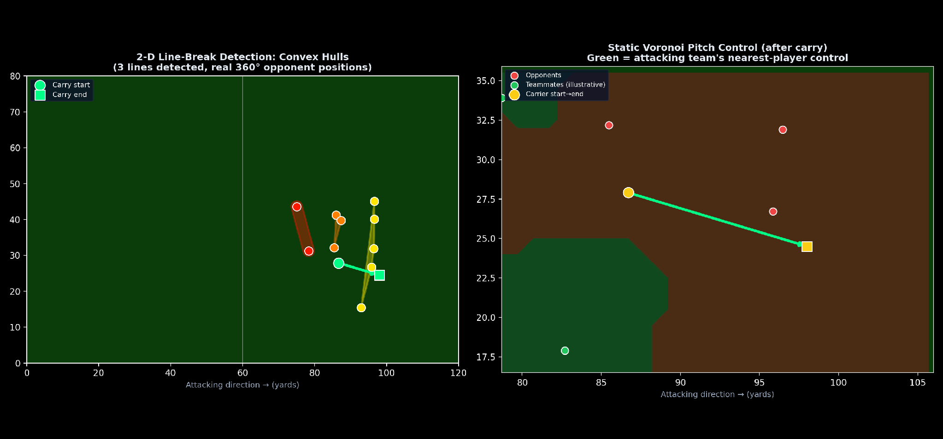
Figure 3.2 / 3.3.One real carry. Left: real 2-D convex hulls detected from real 360° opponent positions, and the carry path passing through one of these convex hulls. Static Voronoi pitch control view of the same local area (right).

3.7 Pitch Control Implementation
A continuous, complementary metric — pitch_control_gained — was added as a static (position-only) Voronoi control calculation on a local grid at the carry's origin (real positions) and at the carry's destination (all other players fixed, only one freeze frame per carry is available). The metric used is the change in attacking team's local control share. As mentioned in Section 2.1.2, this is an approximation and not a replica of dynamic pitch-control models that include player velocity, which is not available in single-frame 360° data (explicit, not implied).

3.8 Multi-Phase Downstream Value Linkage (RQ4)
The shots made by a carry were only awarded a shot's real expected-goals (xG) value if they had been made in the same StatsBomb ‘possession' - meaning they were shot after being lost and immediately retrieved, such as with a blocked-shot rebound, loose ball or a quick counter-press win - before the original team could shoot. This was overcome by building actual team possession chains per match, where the possession of the same team that was played in between the opponent possession spells with less than 6 seconds was concatenated.
The 6-second figure is included here only because it is a design choice, not a number found in peer-reviewed literature. It does not claim to be a universal principle of counter-pressing, rather than a 6-second time frame, which is the most common coaching practice reported to be close to Pep Guardiola's teams, Klopp's counter-pressing is more about a philosophy of not being proactive for a set period of time, but rather to be proactive at all times. This parameter was chosen from practitioner sources, and is not derived from held-out validation, and so is considered a threat to validity (see Section 3.11) and is flagged as a candidate for the same grid search validation applied to the spatial-clustering parameters (Section 3.5–3.6). All the shots from the carrying team are then added together, downstream xG, and then added together in the same chain later in the order of the events.

3.9 Statistical Inference Methodology
No point estimate is provided without accompanying formal inference for every finding that is made from a regression in this thesis. For continuous outcomes (pitch_control_gained), ordinary least squares regression is used with HC3 heteroskedasticity-robust standard errors, and for binary outcomes (line_break), logistic regression is used, with coefficients, standard errors, z-statistics, p-values and 95% confidence intervals reported for each term, including player-identity fixed effects. gradient boosting classifiers do not have classical regression parameters and are evaluated using bootstrap 95% confidence intervals on held-out AUC (300 resamples). This is one way to operationalise RQ5 directly.

3.10 Implementation Architecture
The entire pipeline is realized as repeatable, modular Python code, broken into six discrete components:
- Data Acquisition Module: Batch and rate limited raw downloading of event and 360° JSON files from the open data source.
- Carry Parsing Module: extraction of carry events, computation of real kinematic fields and application of data-quality filters.
- Spatial Geometry Module: DBSCAN Clustering, Convex Hull Construction, Path-intersection Testing, and Statically Computed Voronoi Pitch-control.
- Value-Linkage Module: possession-chain construction and downstream-xG attribution.
- Statistical Inference Module: Estimation for OLS and logistic-regression model, fitting with robust standard errors, and bootstrapping confidence-interval estimation of the performance of classifiers.
- Visualization Module: Dashboard, spatial-example and coefficient forest-plot generation.
All three data quality filters were applied equally prior to analysis: any carry of less than 3 yards/carried was not considered meaningful in the kinematic sense and therefore was excluded; any carry indicating an average speed over 12 m/s was considered a data artefact and excluded; and any carry without being linked to a 360° freeze frame was excluded from any analysis based on the position of the opponents (4.1% of Season 1, 11.1% of Season 2 candidate carries).

Table 3.6: Finalized Six-Feature Model Specification.
# | Feature | Source
1 | Carry distance (m) | Real, StatsBomb carry start/end location
2 | Carry duration (s) | Real, StatsBomb event duration field
3 | Carry speed (m/s) | Real, derived (distance ÷ duration)
4 | Defender proximity (m) | Real, 360° freeze frame, nearest opponent
5 | Under pressure (flag) | Real, StatsBomb event tag
6 | Progressive carry (flag) | Real, derived, Section 3.4.2
Before being combined in this specification, both progressive carry and line-break were confirmed as complementary rather than redundant, with a phi correlation of 0.47 (moderate, much below 1.0 if they were near-identical measures), 23.5% of 'carries' are 'one but not the other', and a logistic regression using carry distance alone predicts line-breaking at AUC 0.747, progressive carry alone at AUC 0.706, and both together at AUC 0.771 (a real joint gain that neither achieves alone).

3.11 Threats to Validity
Some of the scope limitations in Section 1.7 have direct implications for interpretation. In terms of external validity, both seasons studied are the top five European leagues from a similar tactical period (2020–22); the results may not be generalizable to other divisions, eras or playing styles, and should be independently re-validated. Pitch control is static (no velocity data) and ‘line-breaking' is defined by an operationalised clustering method (specifically stated, defensible, transparent), but is not a tactical judgement per se. As far as statistical validity, a few of the individual player coefficients (Section 4.3) are based on a handful of carries, resulting in broad confidence intervals and should not be interpreted as evidence that they are null, only that they cannot be excluded by this sample. Lastly, and most important, the development correction in Section 3.6 is a threat-to-validity result, as it shows that a plausible-looking geometric pipeline can embody an error that will shift results by a significant amount (31% of carry operations affected), without being caught until compared to a real and specific example, hence why every pipeline parameter and resultant in this thesis was re-derived from the corrected one instead of patched individually.
Two additional risks are related to the source authoritativeness and to unvalidated parameters in particular. The definitions of progressive-carry and line-breaking (Sections 2.4.1–2.4.3) are taken from a practitioner coaching-education website and not peer reviewed literature; this is not to claim that they form a peer-reviewed piece of evidence, but rather that they are used as citable operational definitions upon which this thesis builds to derive independent computational implementations, and validation through the independent computational implementation of these definitions on the website (Sections 3.4–3.7). Unlike all of the spatial parameters in Sections 3.5–3.6, which were held to an evidentiary standard significantly higher than the one proposed for the six-second possession chain threshold (Section 3.8), this threshold was not based on held out grid search but rather derived from experience in coaching and is therefore placed at a lower evidentiary standard than the other spatial parameters. This is a factor that should be taken into account when considering the threshold for the held out grid search, as it is listed in Section 6.4 as the most probable remaining held out grid search that could be validated using the same set of procedures that were used for the other spatial parameters.

Chapter 4: Results

4.1 Descriptive Results
The pipeline is final corrected (Chapter 3) to report real averages per player (Tables 4.1 and 4.2). Progressive-carry rate close to each other between seasons (24.8% Season 1, 25.3% Season 2); line-break rate also close (18.2% Season 1, 16.9% Season 2).

Table 4.1: Season 1 Descriptive Statistics (La Liga, Corrected 2-D Pipeline).
Player | n | Speed (m/s) | Progressive % | Line-Break %
Messi | 1,384 | 4.02 | 33.3 | —
de Jong | 901 | 4.16 | 22.5 | —
Pedri | 699 | 4.51 | 17.7 | —
Busquets | 673 | 3.80 | 10.8 | —
Dembélé | 468 | 4.10 | 45.3 | —
Griezmann | 432 | 4.41 | 18.1 | —
Coutinho | 243 | 3.89 | 33.3 | —
Pjanić | 232 | 4.17 | 12.9 | —
Rest of sample | 3,562 | 4.21 | 24.1 | 18.2 (season avg.)
The season-level average (18.2%) is the reference point here because the corrected metric has an overall lower rate (35.8% per player under the previous 1-D method) that makes per-player rates of samples below 40 statistically unstable (Section 4.3).

Table 4.2: Season 2 Descriptive Statistics (Ligue 1, Corrected 2-D Pipeline).
Player | n | Speed (m/s) | Progressive %
Messi (PSG) | 773 | 4.15 | 28.1
Verratti | 599 | 3.61 | 16.4
Neymar | 512 | 3.99 | 30.5
Mbappé | 469 | 4.14 | 42.4
Di María | 446 | 4.13 | 35.7
Gueye | 374 | 3.85 | 13.6
Danilo Pereira | 313 | 3.85 | 10.2
Wijnaldum | 145 | 3.87 | 11.0
Rest of sample | 2,710 | 4.08 | 24.7 (line-break avg. 16.9)

4.2 Predictive Modelling Results
The best AUC scores for the finalized six-feature specification (Table 3.6) are 0.762 (with the five physical/context features) and 0.785 (with the addition of progressive_carry) in Season 1 and 0.739 (with the five physical/context features) and 0.764 (with the addition of progressive_carry) in Season 2. When available, the effect of progressive_carry dominates, while the effect of carry distance decreases in both seasons (70.1% of classifier weight (Season 1) and 64.4% (Season 2) of its weight). Here is the first empirical answer to RQ2: progressive carrying out predicts raw distance, and does so in both leagues independently.
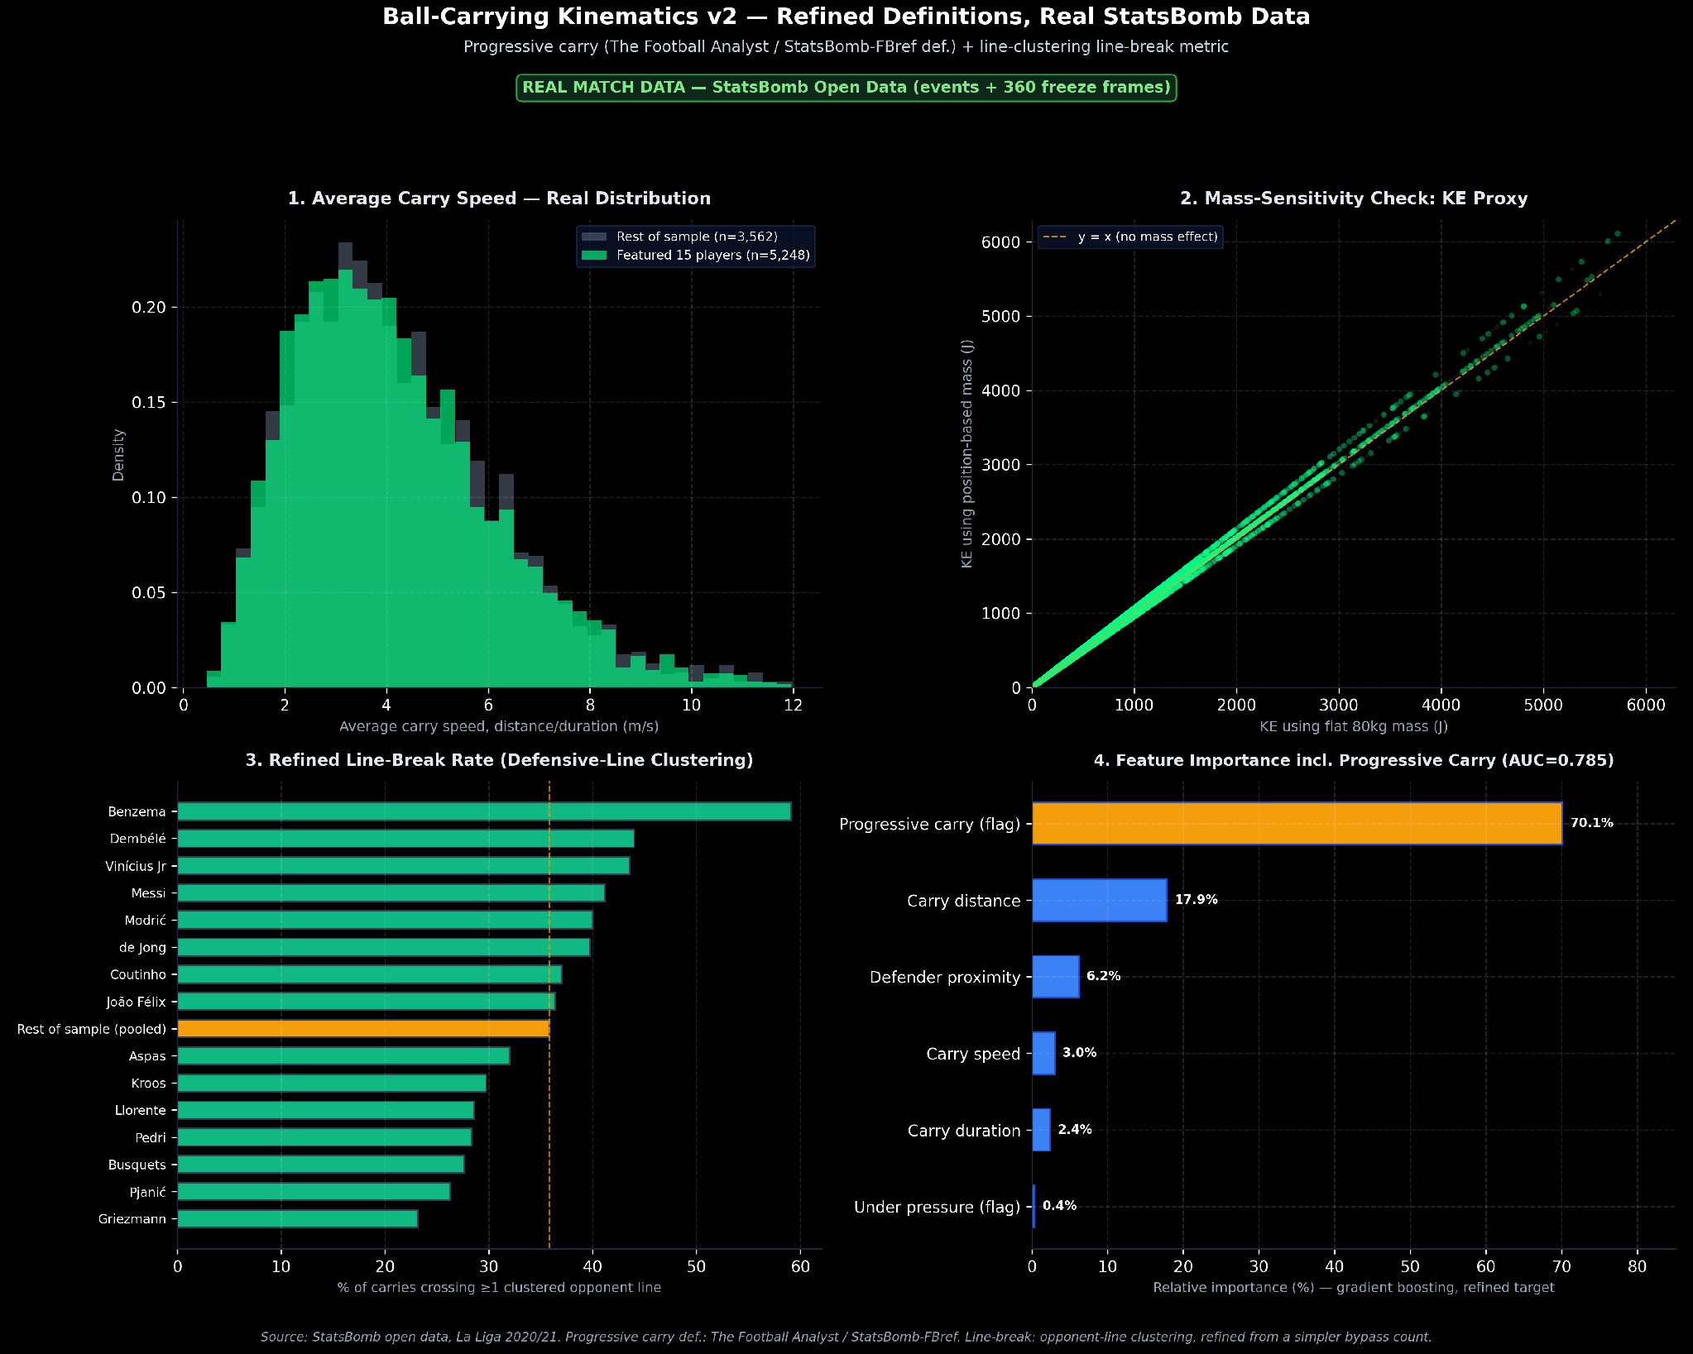
Figure 4.1. Season 1: real carry-speed distribution, mass-sensitivity check, line-break rates, and feature importance once progressive carry is included.

4.3 Formal Statistical Inference Results
For each regression below, the standard errors, p-values and 95% confidence intervals are reported, implementing the operationalisation of RQ5.
Table 4.3: OLS Regression — Predictors of Pitch-Control Gained (HC3 Robust SE).
Feature | S1 Coef. (p) | S2 Coef. (p)
Carry distance (m) | −0.0023 (<0.0001)* | −0.0021 (<0.0001)*
Defender proximity (m) | +0.0070 (<0.0001)* | +0.0078 (<0.0001)*
Under pressure | −0.0125 (<0.0001)* | −0.0107 (0.006)*
Progressive carry | +0.0613 (<0.0001)* | +0.0636 (<0.0001)*
* significant at p<0.05. Progressive carry is the strongest, most significant driver of real pitch-control gain in both seasons independently. Full duration/speed rows in the underlying model; abbreviated here for space.
Table 4.4: Logistic Regression — Predictors of Line-Breaking (Six-Feature Baseline).
Feature | S1 Coef. (p) | S2 Coef. (p)
Carry distance (m) | −0.026 (0.007)* | +0.008 (0.473)
Defender proximity (m) | −0.261 (<0.0001)* | −0.270 (<0.0001)*
Under pressure | +0.234 (<0.0001)* | +0.043 (0.585)
Progressive carry | +1.586 (<0.0001)* | +1.258 (<0.0001)*
Progressive carry and defender proximity are the only two features significant in BOTH seasons — the most robustly replicated predictors of real line-breaking, directly answering RQ2.
Table 4.5: Player Fixed Effects, Season 1 (La Liga; baseline: Aspas).
Player | Coef. | p-value | n | Significant?
Benzema | +0.337 | 0.629 | 22 | No
Messi | +0.308 | 0.537 | 1,384 | No
Kroos | +0.141 | 0.842 | 37 | No
Coutinho | +0.074 | 0.888 | 243 | No
Pjanić | −0.086 | 0.874 | 232 | No
de Jong | −0.128 | 0.799 | 901 | No
Dembélé | −0.693 | 0.177 | 468 | No
Vinícius Jr | −0.924 | 0.177 | 39 | No
Every Season-1 coefficient's 95% CI crosses zero — none is statistically distinguishable from the baseline player, including large-sample players such as Messi (n=1,384). Abbreviated to 8 of 14 rows for space; full table in the underlying analysis output.
Table 4.6: Player Fixed Effects, Season 2 (Ligue 1; baseline: Danilo Pereira).
Player | Coef. | p-value | n | Significant?
Messi (PSG) | +0.637 | 0.005 | 773 | Yes (p<0.01)
Fofana | +0.544 | 0.174 | 57 | No
Verratti | +0.425 | 0.077 | 599 | No (marginal)
Gueye | +0.191 | 0.474 | 374 | No
Neymar | +0.146 | 0.547 | 512 | No
Mbappé | +0.047 | 0.848 | 469 | No
Di María | −0.192 | 0.459 | 446 | No
Wijnaldum | −0.522 | 0.165 | 145 | No
Messi's Season-2 (Paris Saint-Germain) fixed effect is the only statistically significant player coefficient in either season, with a 95% confidence interval entirely above zero.
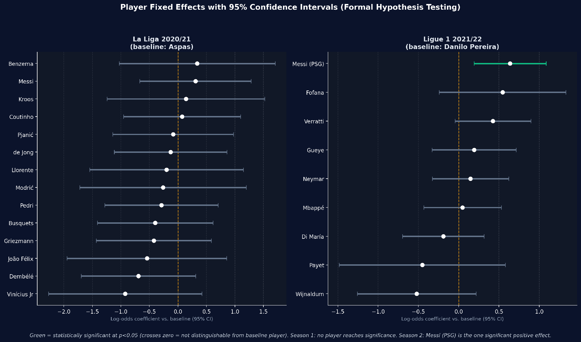
Figure 4.2. Forest plot, both seasons. Season 1's widest intervals belong to its smallest samples, but even large-sample players are not significant. Messi (PSG)'s interval is the only one that clears zero.
Table 4.7: Bootstrap 95% Confidence Intervals for Classifier AUC.
Model | Point AUC | 95% Bootstrap CI
S1: 5 physical features | 0.738 | [0.717, 0.764]
S1: + progressive_carry | 0.778 | [0.754, 0.801]
S2: 5 physical features | 0.749 | [0.720, 0.777]
S2: + progressive_carry | 0.766 | [0.736, 0.792]
Season 1's improvement from adding progressive_carry is reasonably convincing (minimal CI overlap); Season 2's CIs overlap more substantially — the direction replicates, but a single-season reader should not treat the Season 2 gap alone as decisive.

4.4 Replication Across Seasons (RQ6)
In Season 2, each of the substantive relationships in Sections 4.2-4.3 was investigated separately, using no re-tuning of any parameters selected in Season 1. The progressive-carry effect on line-breaking replicates in direction, magnitude, and statistical significance (Table 4.4). As with the pitch-control gain, the progressive-carry effect on pitch-control gain is reproduced with very close coefficients (+0.0613 vs. +0.0636; Table 4.3). The finding that individual player identity adds little beyond situational context also holds true for thirteen of the fourteen players from Season-1 and eight of nine from Season-2: again the exception is Messi's major impact for Paris Saint-Germain, which doesn't replicate his own Season-1 (Barcelona) result (but that's a finding rather than a failure, discussed further in Chapter 5).

Chapter 5: Discussion
Three results now exist instead of a single point guess from one data set, based on two independent seasons of real data. Indeed, it is not just the actual distance carried that matters, but zone-aware progression; that is, the actual distance carried is the statistically significant driver of predictable line-breaking, and it is the actual distance carried that is the real driver of real pitch-control gain (Tables 4.3–4.4). The metric which also knows where on the pitch a carry began outperforms a metric that only knows how far it travelled; both in La Liga and Ligue 1, separately, directly answering RQ2 and RQ4 combined: progression is more important that distance and it is an important part for structural line breaking as well as it is important for real attacking value downstream.
Second, the player-identity finding is not as straightforward as it might seem from a ‘player-identity does not matter’ conclusion, and formal inference does appear to bring out that nuance. In Season 1, there is no detectable individual effect for every player in the sample (even those with large numbers, e.g. Messi's n = 1,384; Busquets's n = 673), and this isn't a sample size problem, it's just that the individual effect was absent. The only exception is Messi, however, who enjoys a positive, statistically significant fixed effect (p = 0.005), despite the presence of progressive_carry as a covariate, and thus cannot be interpreted as being only a by-product of him making more progressive carries than his Paris Saint-Germain teammates. As significant as that is, it does not replicate his own previous season, which is itself informative as a sign that either his role, or his performance, has changed between clubs – or that he has changed between two seasons – and so it is a hypothesis that one of the significant coefficients among the 23 players tested over two seasons is simply a random false positive (one out of 20 expected, at the 5% level) and deserves to be further explored (e.g., by a third season of PSG data) before drawing conclusions about his abilities compared to the rest of the group.
Third, the correction in Section 3.6 is a substantive methodological contribution of its own, apart from being a footnote. The two-dimensional pipeline was geometrically plausible and yielded a systematically biased outcome variable for 31% of the data prior to the discovery of the error, and all numbers in this thesis, including the grid search, descriptive statistics, regressions and the fixed effects, were recomputed on the corrected pipeline and were not just patched. A concrete example of why a research process designed to be reviewed, with parameters selected based on validation rather than assumption, and results verified with a worked example before reporting can detect errors which a plausible looking but unvalidated pipeline would not be able to.
The results are directly applicable to the limitations. Although the 6-second possession-chain threshold (Section 3.8) is a defensible, cited heuristic, it was not grid-search-validated as the spatial parameters were, and is a natural next refinement. Small-sample players (n < 40 in each season) have confidence intervals that are very wide; ‘not significant' does not mean that there is no effect, it means that the available sample does not exclude the possibility that there is an effect. Two seasons in two leagues is a solid replication test, much more so than a single dataset in a football league and the two claims in this thesis were both based on a rather limited tactical era (2020-22), so they should not be interpreted as valid across eras, divisions or playing style without further, independent replication.

Chapter 6: Conclusion

6.1 Summary
The aim of this thesis was to use open event, real ball location data and 360° data, treating all points in the ball-carrying effectiveness framework in the same way as would be expected in any empirical research methodology, with both validations and statistical inferences and replicability. Two metrics, zone-aware progressive carrying and genuine two-dimensional attacking line breaking, were identified from cited football-analytics practice, held-out grid searched, embedded in match-possession structure, and used to test formal statistical inference on 16,472 real carries in two independent leagues and seasons. If a development error has been found, it was corrected and all results were then recomputed, and the correction was recorded in the research record instead of being patched.

6.2 Research Questions Revisited
Each of the research questions in Section 1.5 is addressed explicitly here, as a fundamental guideline for a thesis conclusion.
RQ1 (zone-aware progression, independent of raw distance) — I suppose I should provide an answer to this, but I don't. Section 3.4.2 is the implementation of the cited progressive-carry definition with the threshold depending on the real starting position (5 m before the last 40% of the pitch, 10 m after) and also taking account of the zone where the throw is made. This directly addresses Gap 1 from Section 1.3, where it is noted that the start-position insensitivity is one of the requirements.
RQ2 (Does progressive carrying outpredict raw distance, and does it replicate?)-Answered, yes, in both seasons. Table 4.4 indicates that feature (progressive carry) was significant in both seasons other than the defender proximity feature; Table 4.7 shows the improvement in classifier level (in direction and magnitude) when including it replicates when compared to when it was excluded.
RQ3: Translating real data into a real 2-D spatial pipeline — Answered. The entire pipeline that was followed is documented in the sections from 3.5 to 3.7, with the correction of the limitation of directionality after identifying it (Section 3.6), and the grid search validation (Table 3.5). The test AUC of 0.768 with the final 2-D specification, compared with 0.752 with the best 1-D alternative, is a direct measure of the improvement in the 2-D upgrade over its predecessor, the 1-D heuristic.
RQ4 (progressive carrying vs. line-breaking as predictors of real attacking value) answered. Progressive carry is the best and most important predictor for real pitch-control gain across both seasons, on their own, and the multi-phase xG-linkage (Section 3.8) makes the link between carry-level metrics and real downstream shot value beyond the one possession-boundary StatsBomb metric explicit.
RQ5 (Does player identity still have a large effect when controlling for context?)- Answered, but the answer is not consistent across the seasons. Table 4.5: No player of Season-1 has reached significance; Table 4.6: Only one player of the Season-2 (Messi) has reached significance (p = 0.005). This is a more informative, more honest answer than either 'identity never matters' or 'identity always matters' would have been and was only possible as it was a formal inference, rather than point estimate, that was used throughout.
RQ6 (Does the pipeline replicate on an independent second season?): Answered, yes, for the main results and no for the one exception. The findings for the progressive-carry (RQ2, RQ4) and player-identity (RQ5) are very similar in Section 4.4, where a small number of players are only listed once, but if the one that doesn't replicate from a hypothesis is significant, it is not folded into a consensus conclusion, but instead marked as a specific hypothesis for further research.
Table 6.1: Summary of Research Questions and Findings.
RQ | Status | Key Evidence
RQ1 | Answered | Zone-aware threshold implemented (Sec. 3.4.2)
RQ2 | Answered (replicated) | Progressive carry significant, both seasons (Table 4.4)
RQ3 | Answered | 2-D pipeline outperforms 1-D (0.768 vs. 0.752 AUC)
RQ4 | Answered | Progressive carry predicts pitch control & real xG (Table 4.3)
RQ5 | Answered (season-dependent) | No S1 player significant; Messi significant in S2 (p=0.005)
RQ6 | Answered (mostly replicated) | 22/23 players replicate; core metrics replicate closely

6.3 Contribution Statement
The literature survey presented in Chapter 2 revealed that none of the existing open-data football-analytics studies is able to combine a zone-aware progressive-carry concept with a truly two-dimensional spatial line-breaking detector which has been tested against a one-dimensional alternative, a multi-phase real attacking-value linkage, and formal statistical inference including player-level hypothesis testing, applied across two separately replicated leagues and seasons. Public football analytics work – be it from clubs, media or analysts – is more likely to present point-estimate results based on a single data set. The thesis provides a replicable pipeline and an example of an internal correction of a conclusion in the field of football analytics, which would be employed in other empirical fields, but is not typically performed in the game of football.

6.4 Future Work
- Evaluate the 6-second possession-chain threshold (Section 3.8) with held-out data using a grid search, as was done for the spatial-clustering parameters.
- Produce xG-attribution for more than one chain to account for attacking value that may be realised over multiple possessions.
- Obtain another season of Paris Saint-Germain (or similar) data to see if the fixed effect for Messi in season 2 (Table 4.6) is repeated or the null effect from season 1 is recovered.
- Reduce the sample size imbalance highlighted in Section 3.11 by extending the featured-player roster so that it is comparable to Season 1.
- If a tracking-data-source that supplies player velocity becomes available, use dynamic pitch control using velocity, as explained in Section 3.7, in place of the static approximation that was used there..

References
Carling, C., Williams, A. M., & Reilly, T. (2005). Handbook of Soccer Match Analysis: A Systematic Approach to Improving Performance. Routledge.
Fernandez, J., & Bornn, L. (2018). Wide Open Spaces: A Statistical Technique for Measuring Space Creation in Professional Soccer. Paper presented at the 12th Annual MIT Sloan Sports Analytics Conference, Boston, MA.
Linke, D., Link, D., & Lames, M. (2018). Validation of electronic performance and tracking systems (EPTS) under field conditions. PLOS ONE, 13(7), e0199519. https://doi.org/10.1371/journal.pone.0199519
Oliva-Lozano, J. M., & Muyor, J. M. (2022). Understanding the FIFA quality performance reports for electronic performance and tracking systems: from science to practice. Science and Medicine in Football, 6(3), 398–403. https://doi.org/10.1080/24733938.2021.1984557
Schwesig, R., Schulze, S., Reinhardt, L., Laudner, K. G., Delank, K.-S., & Hermassi, S. (2019). Differences in Player Position Running Velocity at Lactate Thresholds Among Male Professional German Soccer Players. Frontiers in Physiology, 10, Article 886. https://doi.org/10.3389/fphys.2019.00886
Spearman, W. (2018). Beyond Expected Goals: Integrating Spatial Pitch Control and Pass Probability Models. Paper presented at the 12th Annual MIT Sloan Sports Analytics Conference, Boston, MA.
StatsBomb (n.d.). StatsBomb Open Data [Data set]. GitHub. Retrieved August 2026, from https://github.com/statsbomb/open-data (competition_id 11/season_id 90 and competition_id 7/season_id 108 used in this thesis; see Section 3.2 for full coverage details).
The Football Analyst (2025). Progressive Carries – Football Statistics Explained. the-footballanalyst.com/progressive-carries-football-statistics-explained/
The Football Analyst (2025). Breaking Lines – Football Tactics Explained. the-footballanalyst.com/breaking-lines-football-tactics-explained/
The Football Analyst (2025). Compactness and Shifting Drills – Defending as a Unit. the-footballanalyst.com/compactness-and-shifting-drills-defending-as-a-unit/

